Image | 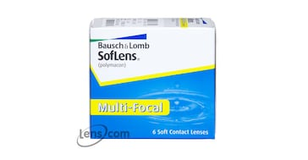
Brand | MICHEAL KORS
Model Name | BAUSH & LOMB SOFT LENS (MULTI FOCAL)
Price | RS 1449
PRODUCT DETAILS

